

FACULTY OF ENGINEERING — CAIRO UNIVERSITY DEPARTMENT OF ELECTRONICS & COMMUNICATIONS
Cross-Clock Domain Data Processing Unit

Name | Section | Student ID
Hazem Ahmed Abd El-Fattah Hassan | 2 | 9220247
Yara Osama Mohtady Idris | 4 | 9220954

Submitted to

Dr. Mohamed Radwan

Academic Year 2025–2026

Table of Contents

Contents
Contents
Table of Contents 2
1. Parallel Prefix Adder 3
1.1 Kogge-stone architecture 3
1.2 Theoretical Background 3
1.3 Architecture Design 4
1.4 Code 4
1.5 Conclusion 4

Parallel Prefix Adder

Kogge-stone architecture
A Parallel Prefix Adder (PPA) is a high-performance digital adder architecture designed to significantly reduce the carry propagation delay that limits conventional ripple-carry adders. It achieves faster arithmetic computation by generating and propagating carry signals in parallel using a structured prefix network based on generate and propagate logic. Among the various parallel prefix architectures, we used the Kogge–Stone Adder which is one of the most prominent due to its minimal logic depth and highly parallel structure, which enables a logarithmic carry computation time. Although it offers excellent speed performance, it comes with increased hardware complexity and wiring overhead. As a result, it is widely used in high-speed arithmetic units, such as microprocessors and digital signal processing systems, where performance is a critical design requirement.

Theoretical Background

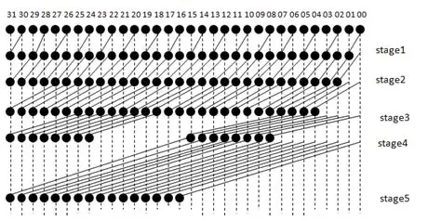
The theoretical background of Parallel Prefix Adders (PPAs) is based on improving binary addition speed by eliminating the linear carry propagation delay found in ripple-carry architectures. In conventional adders, each sum bit depends on the carry generated from the previous stage, resulting in a worse-case delay proportional to the number of bits. Parallel prefix adders address this limitation by reformulating carry computation using generate and propagate signals, which allow carry information to be combined hierarchically. This is achieved through a prefix network that recursively merges carry generate/propagate pairs to compute carries in logarithmic time complexity. The Kogge–Stone adder, a specific implementation of PPA, employs a highly parallel and structured tree network to minimize logic depth, enabling all carry signals to be computed simultaneously. This theoretical approach transforms addition from a sequential dependency problem into a parallel computation problem, making PPAs fundamental in the design of high-speed arithmetic circuits.
Figure 1.32-bit Kogge-Stone Adder tree

Architecture Design

Code

Conclusion
The implementation of the Parallel Prefix Adder using the Kogge–Stone architecture significantly improves computational speed by eliminating the sequential carry propagation found in traditional ripple-carry adders. Instead of waiting for each bit to compute its carry based on the previous stage, the design precomputes carry information in parallel using generate and propagate signals. These signals are efficiently combined through a tree-based prefix network, reducing the carry computation time from linear complexity $O(n)$to logarithmic complexity $O(log⁡n)$. As a result, the critical path delay is minimized, allowing all carry bits to be resolved simultaneously after a small number of prefix stages. This parallelism directly enhances the overall addition speed, making the Kogge–Stone adder one of the fastest adder architectures for high-performance digital systems.
In conclusion, the Parallel Prefix Adder implemented using the Kogge–Stone structure effectively demonstrates a high-speed approach to binary addition by reducing carry propagation delay through parallel computation. The design leverages generate and propagate signals combined in a tree-based prefix network, enabling logarithmic-time carry evaluation and significantly improving overall computational efficiency.

